ST. XAVIER’S COLLEGE

**(Affiliated to Tribhuvan University)**

Maitighar, Kathmandu



DATABASE MANAGEMENT SYSYTEM

Lab Assignment #7

**Submitted by:**

Lokendra Puri  
013BSCCSIT023

**Submitted to:**

|  |  |
| --- | --- |
| Er. Sanjay Kumar Yadav  Lecturer |  |

Department of Computer Science

Date of Submission: September 25, 2015

Creation of tables:

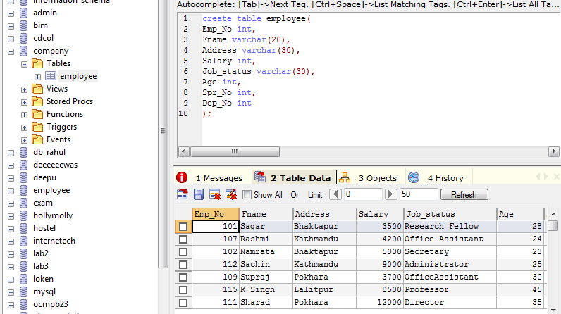

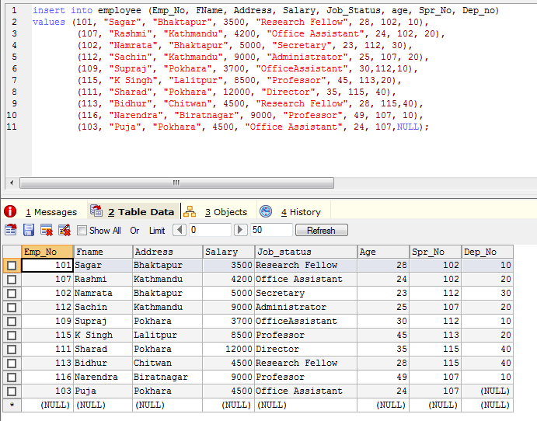

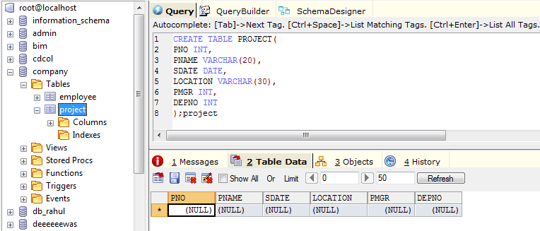

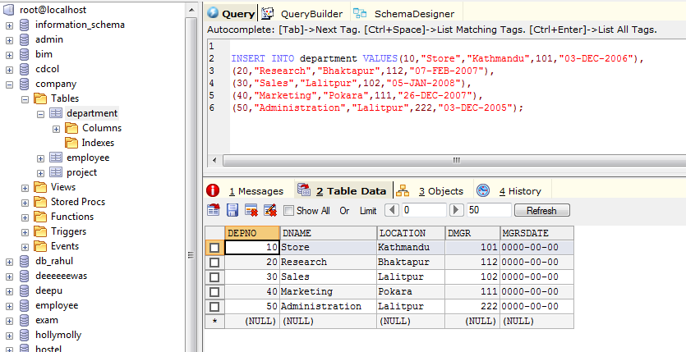

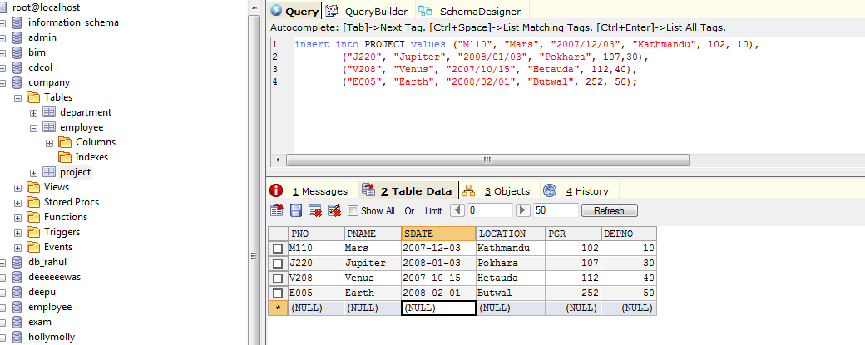

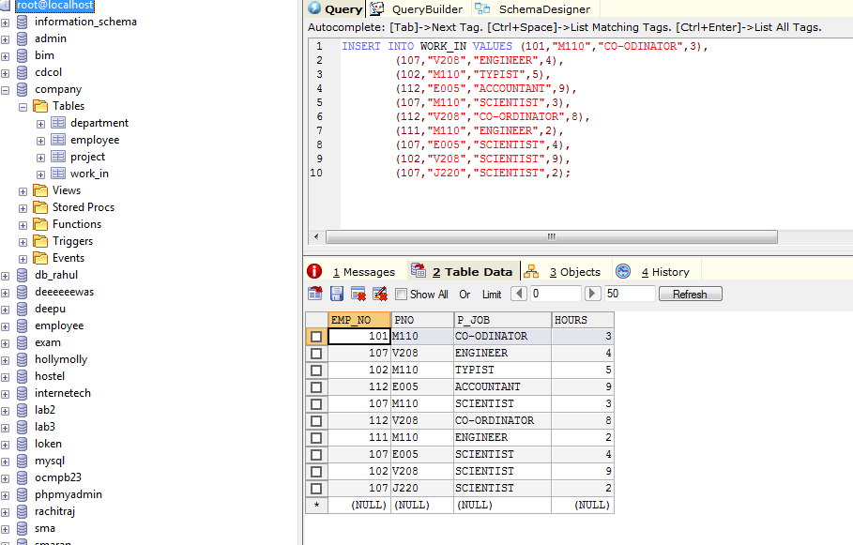

Find the eno,ename ,of the employee whose salary is >4000.

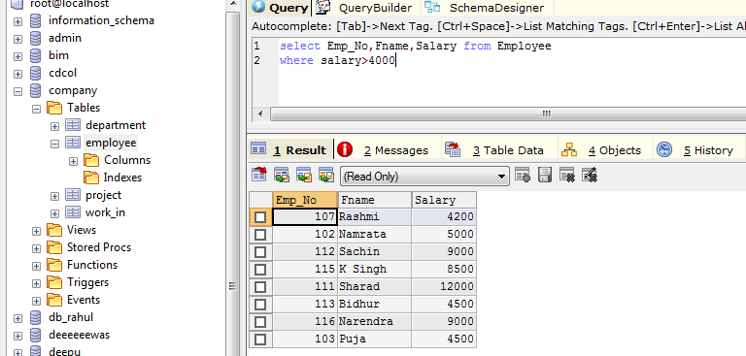

Find the eno, ename and salary of the employee whose salary is greater than 5000 and job status is professor.

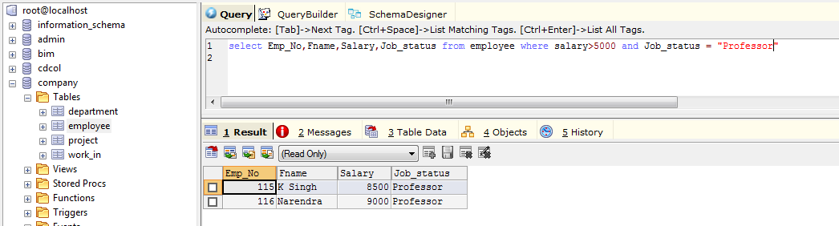

Select address from employee

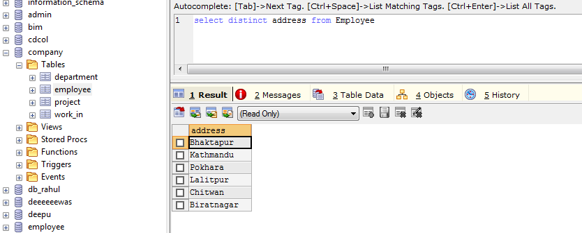

Find the eno enme salary of the employees Whose department no is 20 or job status research fellow

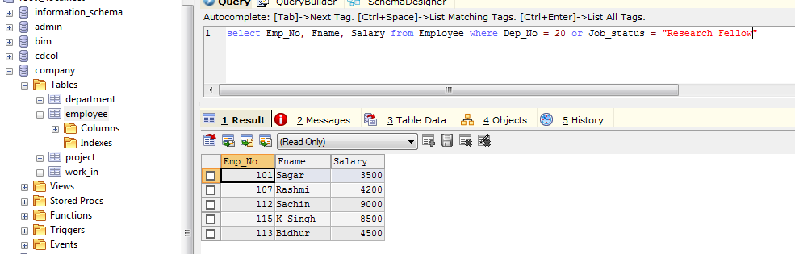

1. List all employee names with their project name.

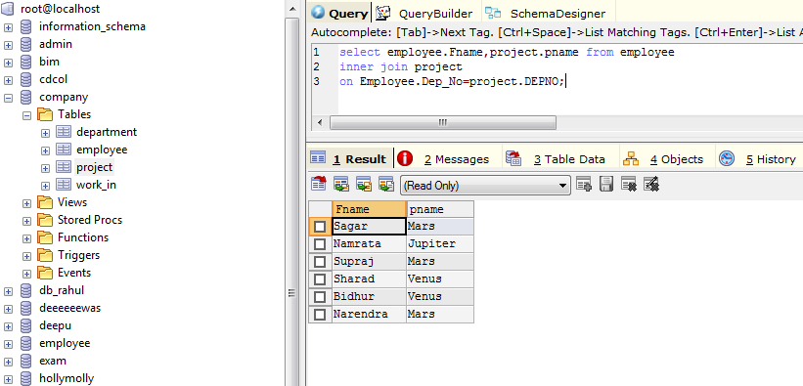

2. List name of all employee and their salary who are working in project MARS or VENUS.

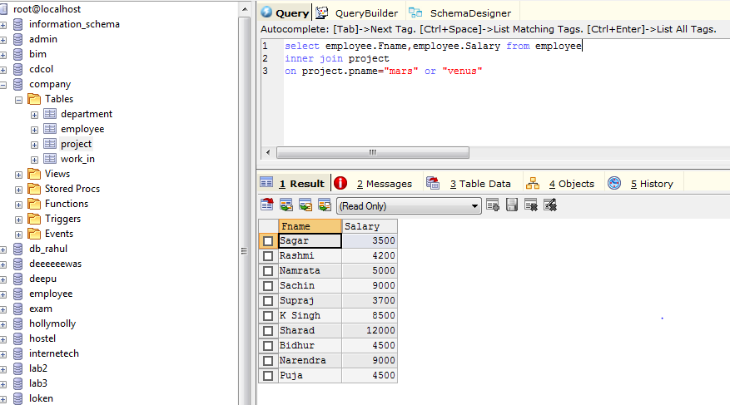

3. List name of all employee and their salary who are working in EARTH and VENUS.

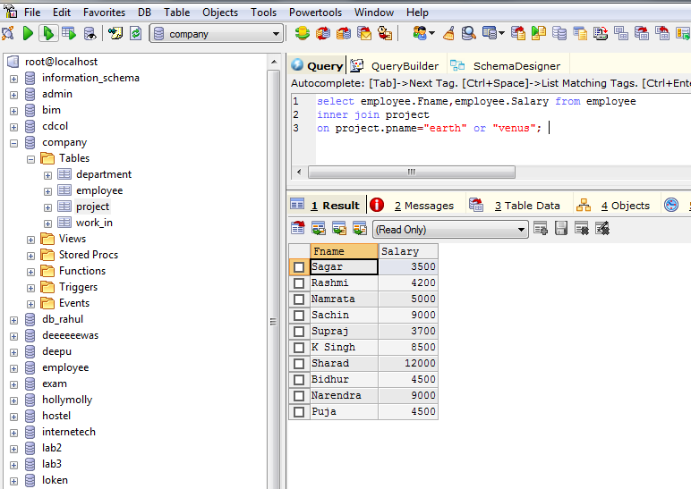

4. List name and address of all employee who are working in department which is located in pokhara